Hawkins Preserve
(A property of the Cortez Cultural Center, Cortez, Colorado)
June, 2019
Dear Friends of Hawkins Preserve,
All around us we see the results of a snowy winter and a rainy spring. Here are some of them.
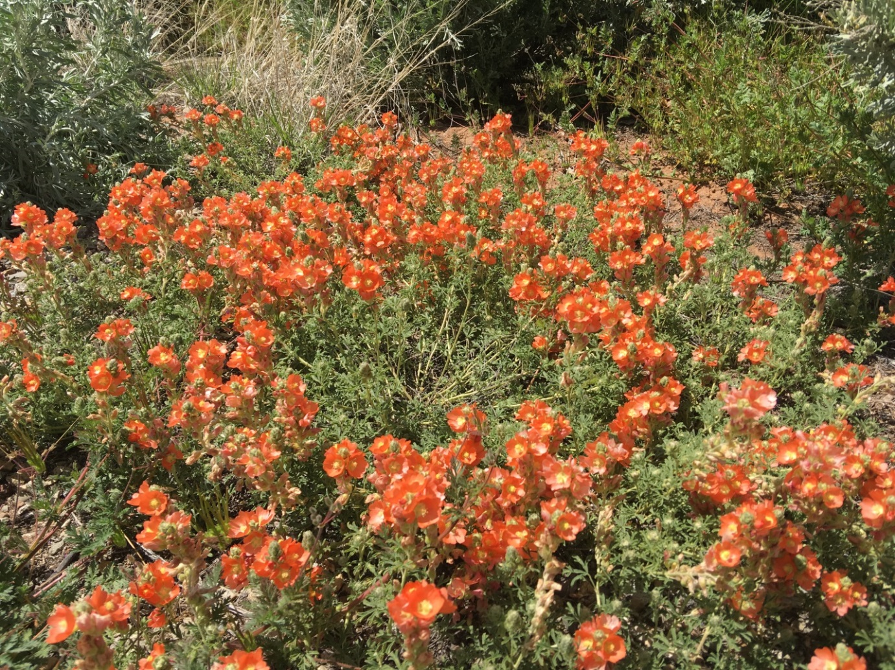
Masses of Orange Mallow
(Orange Mallows have a nice fragrance. Kneel down and try it.)
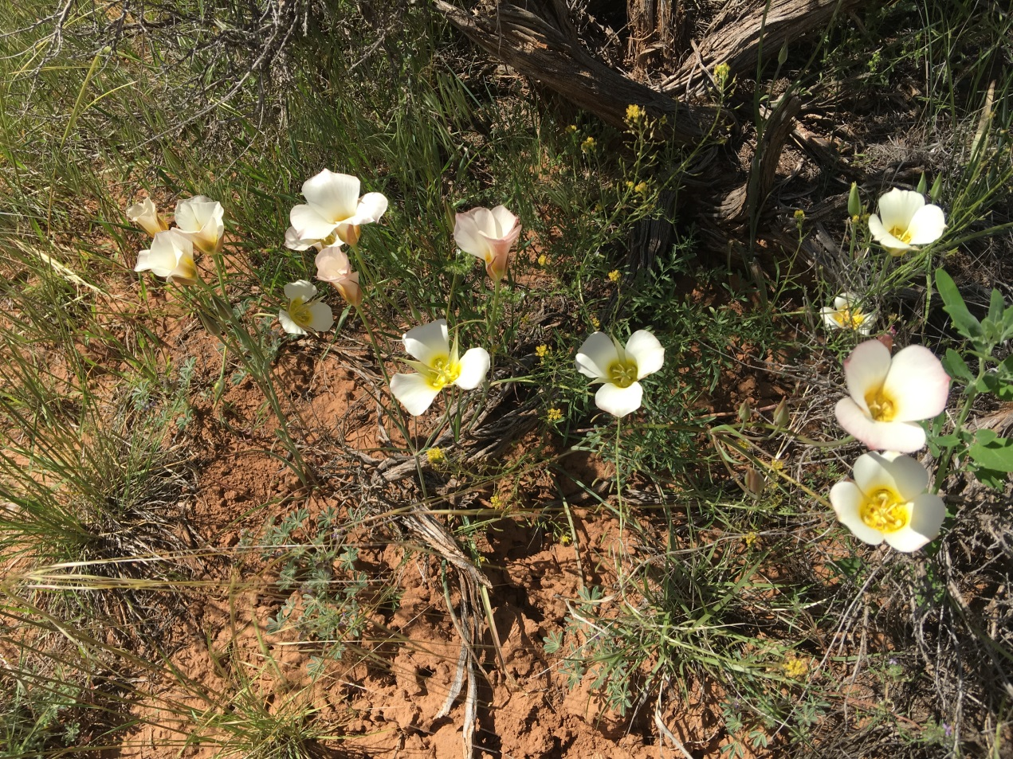
Clusters of Sego Lilies
(The potato-tasting bulbs of Sego Lilies are a valuable food source. In times of
scarcity our Native Americans as well as our early pioneers depended on them.)

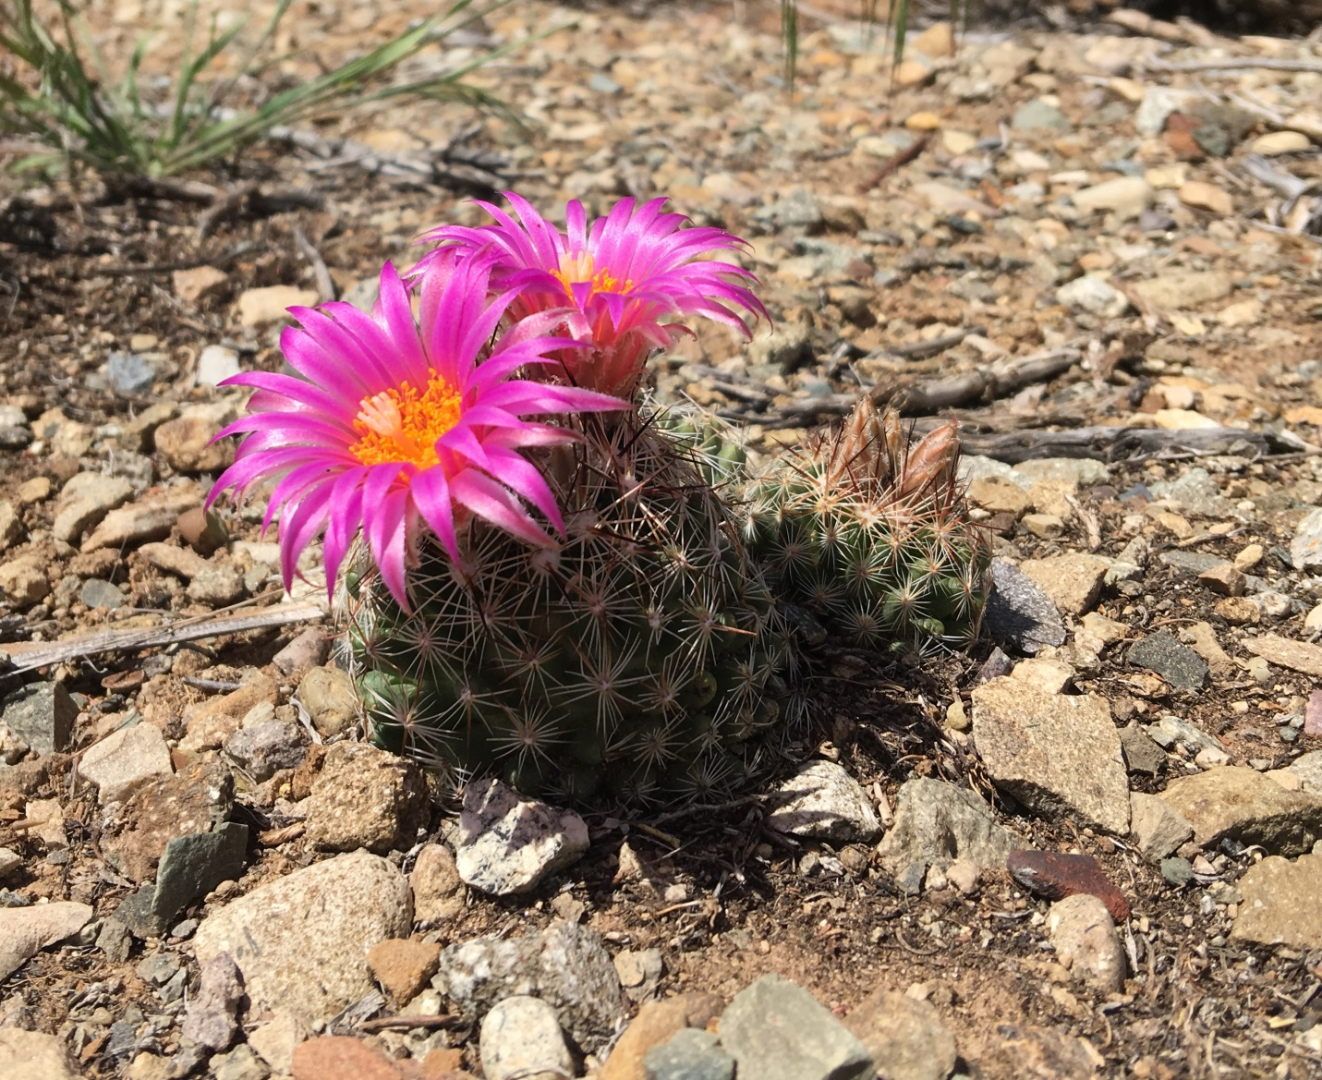
Beehive Cacti
This species of Cacti need a heavy rain to burst into bloom. This often happens in July as a result of our monsoon season. Our recent large spring rains have brought them out now. They typically take root and thrive in tough looking spots such as this.

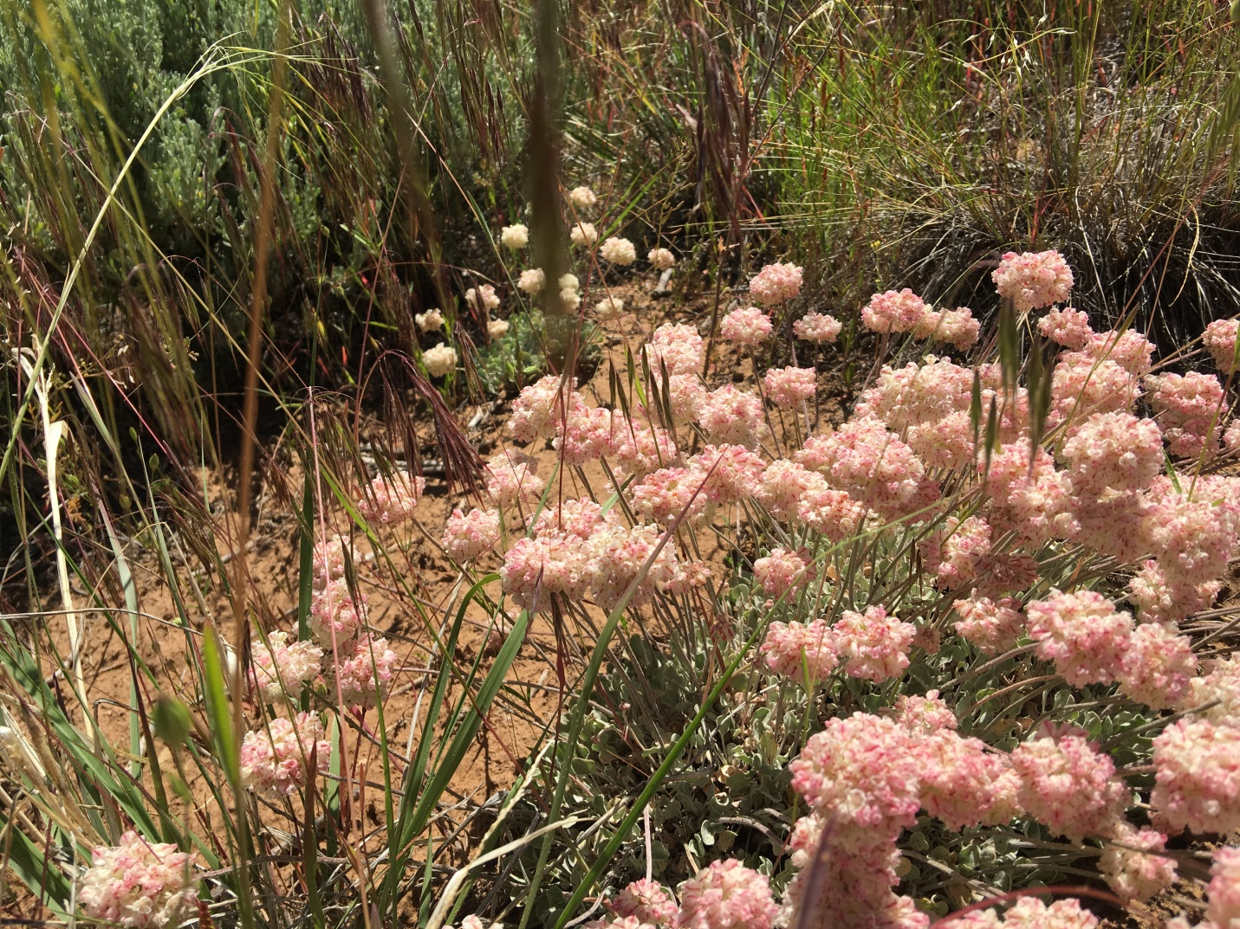
Pussytoes
This is only one variety of these charming little entities. We’ve seen photos of many others,
but these are the real show stoppers, sometimes growing right out of the cracks of the slick rock.

Prickly Pears
The Prickly Pear blooms at Hawkins Preserve exhibit a wide variety of colors from white to deep purple. But within that wide range are subtle variations. Notice the differences among the four reds shown below.
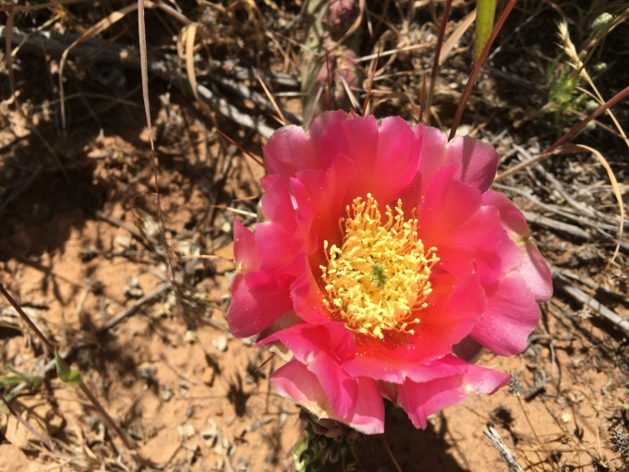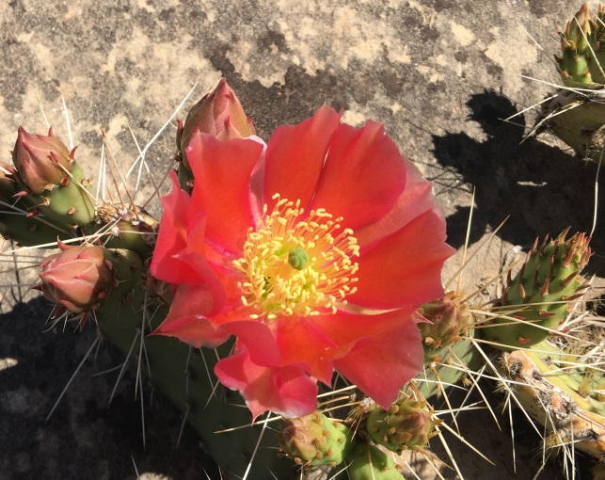
Rose Prickly Pear Scarlet Prickly Pear

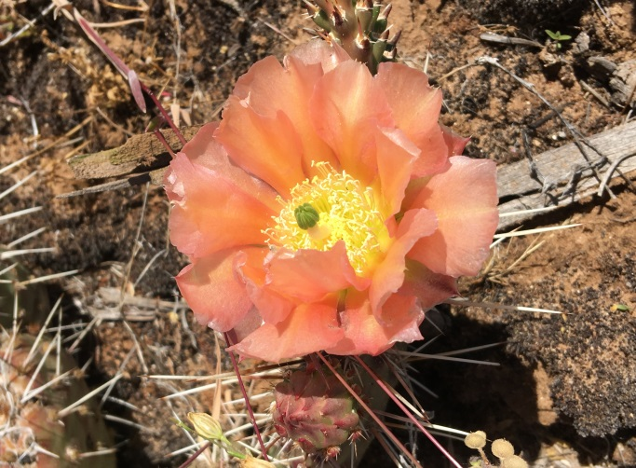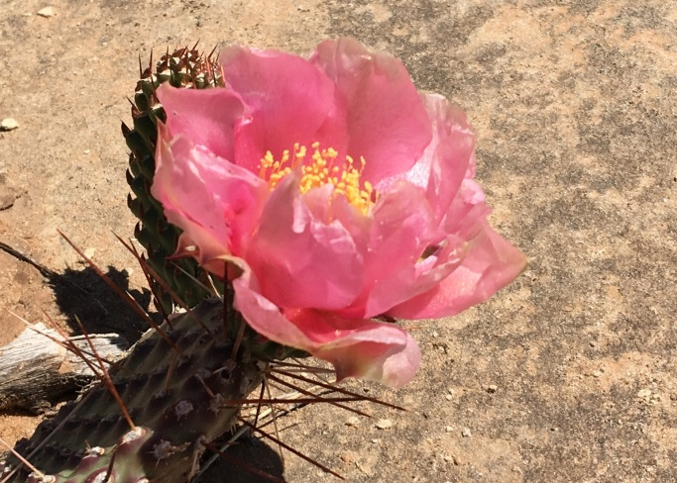
Apricot Pink Prickly Pear Vivid Pink Prickly Pear

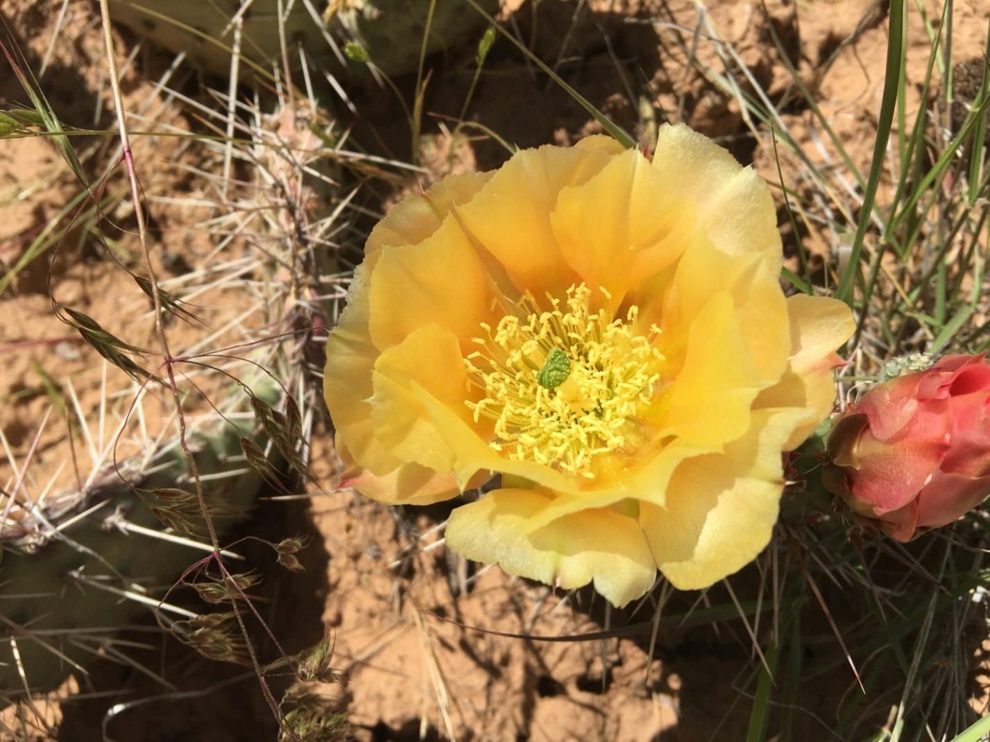
Golden Yellow Prickly Pear
Don’t miss the beautiful hiking weather in the Preserve and the current rainbow of blooms.

Shelby and Roberta Smith - - - - - - - - one more (see below)

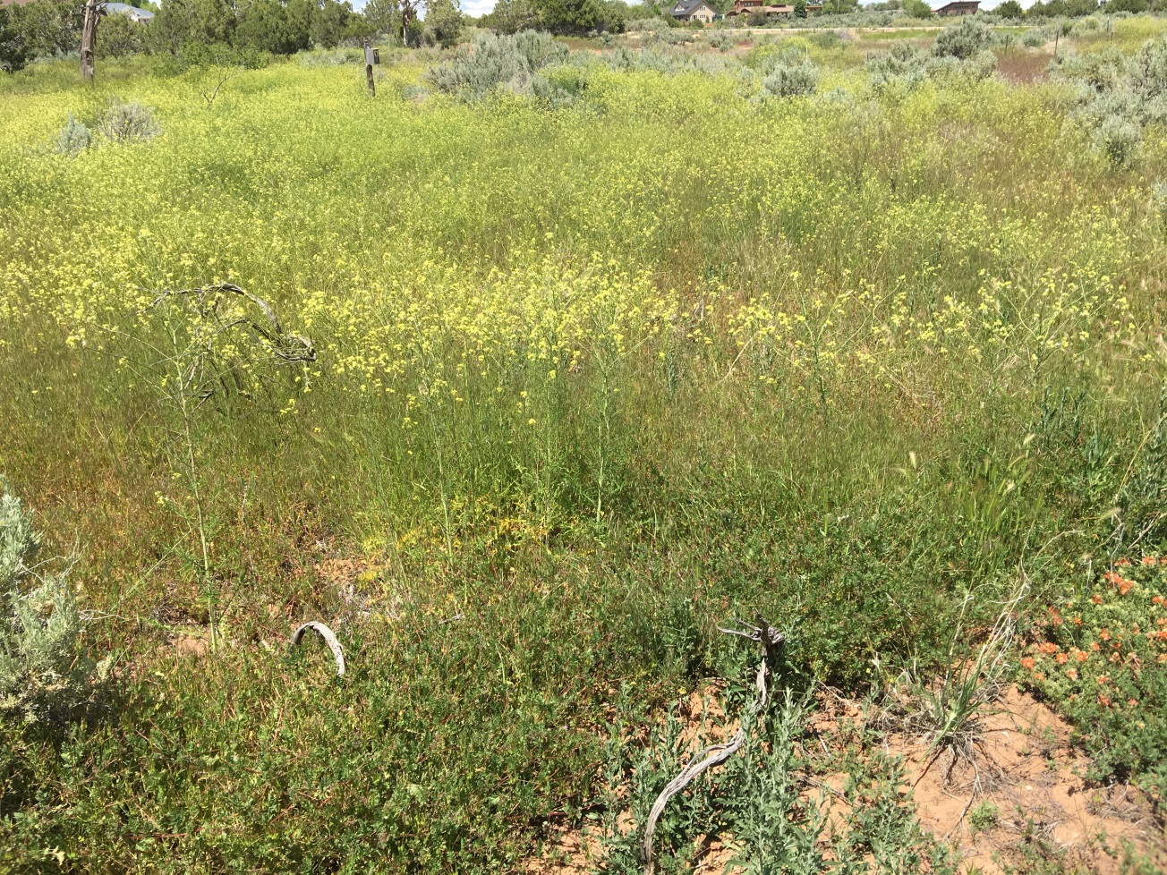
A large patch of Tumble Mustard
The Yellow tumble mustard will bloom, dry, break at its brittle base and tumble away in the breeze. Don’t confuse them with tumbleweeds (Russian thistles). The tumble mustard is not spiny or stickery like tumbleweeds. Volga River German immigrants unintentionally imported tumbleweeds to South Dakota about a hundred years ago. This invasive species soon affected the whole of the American and Canadian West.

